A PROJECT REPORT
on
Smart Dustbin
Submitted in partial fulfillment of the requirement of
Project-III (BIT206CO)
of
Bachelors in Information Technology
Submitted to


Purbanchal University
Biratnagar, Nepal

Submitted By
Bipin Tamang (331852)
Dikshant Khanal (331854)
Soviet Khaling Rai (331877)

KANTIPUR CITY COLLEGE
Putalisadak, Kathmandu
June, 2026

A PROJECT REPORT
on
Smart Dustbin

Submitted in partial fulfillment of the requirements of
Project-III (BIT206CO)
of
Bachelors in Information Technology

Submitted to
Purbanchal University
Biratnagar, Nepal

Submitted By
Bipin Tamang (331852)
Dikshant Khanal (331854)
Soviet Khaling Rai

Project Supervisor
Er. Rabi Shrestha
June, 2026

KANTIPUR CITY COLLEGE
Putalisadak, Kathmandu
June, 2026

TABLE OF CONTENTS
Table of Contents
ABSTRACT iii
ACKNOWLEDGEMENT iv
PREFACE v
DECLARATION vi
SUPERVISOR'S APPROVAL vii
CERTIFICATE FROM DEPARTMENT viii
CHAPTER 1: INTRODUCTION 1
1.1. Background 1
1.2. Problem Statement 1
1.3. Objective 2
1.4. Features 2
1.5. Scope and Limitations 3
Scope 3
Limitations 3
1.5 Hardware Requirements 4
1.6 Hardware Specifications 5
1.7 Organization of Report 6
CHAPTER 2: Literature Review 7
2.1 IoT-Based Smart Dustbin Systems 7
2.2 Automated Lid Indication Systems 7
2.3 Embedded Multi-State Alert Systems 8
CHAPTER 3: System Design 9
3.1 Block Diagram 9
3.2 Circuit Diagram 10
3.3 Algorithm 11
3.5 Tools and Techniques 12
3.6 System Specifications and Key Functions 12
3.7 Testing and Debugging 14
CHAPTER 4: METHODOLOGY AND SCHEDULING 16
4.1 Development Methodology 16
4.2 Project Schedule 16
4.3 Roles and Responsibilities 17
4.4 Gantt Chart 18
CHAPTER 5: CONCLUSION 19
5.1 Limitations 19
5.2 Future Scope 20
CHAPTER 6: REFERENCES 21
APPENDIX A: HARDWARE IMAGES 22

LIST OF FIGURES
Figure No. | Description
Figure 1 | Block Diagram of Smart Dustbin System
Figure 2 | Circuit Diagram (Proteus Simulation)
Figure 3 | Project Gantt Chart
Figure 4 | 89C51 Microcontroller Development Board
Figure 5 | 16x2 LCD Display Module
Figure 6 | Red and Green LED Indicators
Figure 7 | Yellow LED and Buzzer
Figure 8 | Complete Hardware Assembly
Figure 7 | 89C51 Microcontroller Pin Diagram
Figure 10 | 16x2 HD44780 LCD Display Pin Diagram

LIST OF TABLES
Table No. | Description
Table 1 | Hardware Requirements
Table 2 | Pin Connection Details
Table 3 | Tools and Purposes
Table 4 | System Specifications
Table 5 | Key Functions and Descriptions
Table 6 | Test Cases and Results
Table 7 | Roles and Responsibilities

ABSTRACT
Improper waste management is a growing urban challenge, especially in densely populated cities like Kathmandu, Nepal, where overflowing bins lead to health hazards and environmental pollution. This project presents the Smart Dustbin, a microcontroller-based embedded system designed to automatically detect the presence of an approaching object, indicate lid open and close states using LED indicators, monitor the fill level of the bin, and provide real-time local alerts. The system is built around the 89C51 microcontroller using a 16x2 LCD display for real-time status feedback, a tri-color LED system, and a buzzer for audio alerts.
When an object is detected (BTN1), the red LED activates for 3 seconds to indicate the lid is open, then the green LED activates for 3 seconds to indicate the lid has closed, before returning to the ready state. When the bin is half full (BTN2), the yellow LED activates and the LCD shows the status. When the bin is completely full (BTN3), the red LED and buzzer are activated together until the condition clears. The project demonstrates practical integration of embedded C programming, LCD interfacing, and multi-state LED indicator logic on the 8051 microcontroller architecture.

ACKNOWLEDGEMENT
We extend our heartfelt thanks to our project supervisor, Er. Rabi Shrestha, for the constant support, valuable suggestions, and continuous encouragement during every stage of this project. His expertise and insight were crucial for the enhancement of the project.
We also wish to thank Kantipur City College and the Department of IT and Computer Applications for providing the necessary infrastructure and a conducive learning environment for the completion of this project. This was a collaborative team effort, and we appreciate the contribution, patience, and commitment of every team member who worked through the challenges of hardware debugging, code optimization, and system integration to bring this project to completion. Finally, we would like to thank our families and friends for their moral support and encouragement throughout the duration of this program.

Bipin Tamang
Dikshant Khanal
Soviet Khaling Rai

PREFACE
This report documents the design, development, and testing of the Smart Dustbin system, undertaken as a major project in partial fulfillment of the Bachelor of Information Technology program at Kantipur City College, affiliated with Purbanchal University. The idea behind this project arose from the observation that waste management in urban Nepal is largely reactive and manual — dustbins overflow before collection teams are dispatched, leading to hygiene and environmental problems. We wanted to build a practically meaningful embedded system that could automate lid state indication, monitor fill levels in real time, and provide immediate local alerts when bins are full.
Working on this project gave us hands-on experience with several important technical areas, including microcontroller programming in embedded C, hardware interfacing with sensors and actuators, LCD display interfacing, and multi-state LED and buzzer control logic. Each of these areas presented its own challenges, and solving them through research and experimentation was the most valuable part of the experience. We hope that this report serves as a useful reference for students working on similar embedded systems projects and that the system itself demonstrates a practical approach to improving urban sanitation through accessible technology.

DECLARATION
We declare that this project report titled "Smart Dustbin" submitted in partial fulfillment of the Project III is a record of original work carried out by us under the supervision of Er. Rabi Shrestha and has not formed the basis for the award of any other degree or diploma, in this or any other Institution or University. In keeping with the ethical practice in reporting scientific information, due acknowledgements have been made wherever the findings of others have been cited.

Bipin Tamang
Dikshant Khanal
Soviet Khaling Rai

June, 2026

SUPERVISOR'S APPROVAL
This is to certify that the major project entitled "Smart Dustbin" undertaken and demonstrated by Bipin Tamang, Dikshant Khanal, and Soviet Khaling Rai has been successfully completed under our supervision as a partial fulfillment of the requirements for the degree of Bachelors in Information Technology, Semester-III under Purbanchal University. I, henceforth, approve this project to be awarded the certificate by the concerned authority.
During supervision, I found students hardworking, skilled and ready to undertake any professional work related to this field in future.

_______________
Er. Rabi Shrestha
Project Supervisor

Date: June, 2026

CERTIFICATE FROM DEPARTMENT
Following the Supervisor's Approval and Examiners' Acceptance, the project entitled "Smart Dustbin" submitted by Bipin Tamang, Dikshant Khanal, and Soviet Khaling Rai as a partial fulfillment of the requirements for the degree of Bachelors in Information Technology, Semester III, under Purbanchal University, has been officially awarded by this certificate.
We wish the students all the best for their future endeavors.

________________ ________________
Saroj Pandey , Rubim Shrestha ,
HOD Proect Head
Department of IT Department of IT

CHAPTER 1: INTRODUCTION

1.1. Background
Solid waste management is one of the most pressing urban challenges facing cities in developing countries. In Nepal, particularly in the Kathmandu Valley, the rapid growth of urban population has outpaced the capacity of municipal waste management systems. Dustbins overflow before scheduled collection times, creating breeding grounds for disease vectors, emitting foul odors, and contributing to environmental pollution. A key limitation of the current system is that collection teams operate on fixed schedules rather than responding to actual fill levels, resulting in both overflowing bins and unnecessary collection trips to half-empty ones.
Advances in embedded systems and sensor technology have made it feasible to build low-cost, automated smart dustbin systems that can monitor fill levels, indicate lid states via visual indicators, and provide immediate local alerts. This is the motivation behind the Smart Dustbin system developed in this project.

1.2. Problem Statement
The existing approach to waste collection in Nepal relies entirely on manual inspection or fixed time schedules. This approach fails in the following common scenarios:
- Bins overflow before collection teams arrive, causing sanitation hazards
- Manual lid operation requires physical contact, raising hygiene concerns
- No local visual or audio alert system exists to indicate bin fill levels to nearby users or staff
- Waste collection staff have no immediate indication of when a bin needs attention

1.3. Objective
The major objectives of the project are as follows:
- To design and implement an automated smart dustbin using the 89C51 microcontroller with LED-based lid state indication
- To monitor the fill level of the bin and provide real-time status via a 16x2 LCD display
- To provide a red LED indication when the lid is open (3 seconds) and a green LED indication when the lid is closed (3 seconds) after each object detection event
- To provide a yellow LED for half-full state and a red LED with buzzer for the bin full state

1.4. Features
- Object detection via BTN1 triggers lid-open state with RED LED for 3 seconds
- Automatic lid-close state indicated by GREEN LED for 3 seconds before returning to ready
- Yellow LED activates when bin is half full (BTN2)
- Red LED and buzzer activate together when bin is completely full (BTN3)
- Real-time status displayed on 16x2 LCD for all states
- All outputs clear automatically when state conditions are resolved

1.5. Scope and Limitations

Scope
- Real-time bin fill level monitoring with three states: ready, half full, and full
- LED-based lid open and close state indication with timed sequences
- Visual and audio local alerts via LEDs and buzzer
- Functional prototype demonstrated using pushbuttons to simulate object detection and fill level sensors

Limitations
- The current prototype uses pushbutton inputs to simulate object detection and fill levels; ultrasonic sensors would replace these in a production version
- Only local alerts are provided; no remote notification is included in this version
- The system does not include a battery backup; it requires a continuous 5V supply
- The green LED lid-close timer runs for a fixed 3 seconds regardless of actual bin usage

1.5 Hardware Requirements

Component | Description / Purpose
89C51 Microcontroller Board | Main processing unit; 8-bit MCS-51 architecture, 4 KB Flash ROM
16x2 LCD Display | HD44780 compatible, 8-bit parallel interface for real-time status display
LED Red | Indicates lid open state (BTN1) and bin full state (BTN3), connected to P1.1
LED Yellow | Indicates bin half full state, connected to P1.2
LED Green | Indicates lid closed state after object event, connected to P1.3
Buzzer | Audio alert for bin full state, connected to P1.4
Pushbutton x3 | BTN1: object detected (P1.5), BTN2: half full (P1.6), BTN3: full (P1.7)
220 Ohm Resistors | Current limiting resistors for LED indicators
Jumper Wires | Male-to-male and male-to-female connecting wires
Breadboard | For component prototyping and connections
5V DC Power Supply | Powers the 89C51 board and all peripherals
Table 1: Hardware Requirements

1.6 Hardware Specifications
1) 89C51 Microcontroller
- 8-bit microcontroller based on Intel MCS-51 architecture
- 4 KB of on-chip Flash ROM (in-system programmable)
- 128 bytes of internal data RAM
- 32 programmable I/O pins organized as four 8-bit ports: P0, P1, P2, P3
- Two 16-bit timers/counters (Timer 0, Timer 1) and one full-duplex UART
2) 16x2 LCD Display
- Displays 16 characters per line across 2 lines
- Connected in 8-bit mode: data lines D0-D7 connected to Port 2 (P2.0-P2.7)
- Control signals: RS connected to P3.4 (T0), EN connected to P3.5 (T1), RW connected to GND
- Operating voltage: 5V
3) LED Indicators
- Red LED (P1.1): activates for 3 seconds when lid opens on object detection, and also activates for bin full state
- Green LED (P1.3): activates for 3 seconds when lid closes after the object detection open cycle
- Yellow LED (P1.2): activates when bin is half full
- Each LED connected in series with a 330 Ohm current limiting resistor
4) Buzzer
- Piezoelectric buzzer connected to P1.4
- Activated together with Red LED when bin full state (BTN3) is detected
- Remains active as long as BTN3 is held (bin full condition persists)
- Operating voltage: 5V

1.7 Organization of Report
Chapter 1: introduces the project, covering the background, problem statement, objectives, features, scope and limitations, hardware requirements and specifications.
Chapter 2: provides a literature overview of related research and existing systems in the area of smart dustbin and automated waste management systems.
Chapter 3: covers the complete system design including the block diagram, circuit diagram, algorithm, flowchart, tools used, key software functions, and testing results.
Chapter 4: presents the project methodology, team roles, schedule, and Gantt chart.
Chapter 5: concludes the report with a summary of achievements, identified limitations, and suggestions for future improvement.
Chapter 6: lists all references cited in this report in IEEE format.
Appendices: The appendices contain hardware photographs, software screenshots, and component pin diagrams.

CHAPTER 2: Literature Review
A review of existing work in the area of smart dustbins, automated waste management systems, and embedded indicator systems was carried out to understand the current state of the technology and to identify what this project adds to the existing body of work.

2.1 IoT-Based Smart Dustbin Systems
A number of research projects have explored smart dustbin designs using microcontrollers combined with ultrasonic sensors for fill-level detection and wireless modules for real-time notification. The general approach involves continuously reading the distance from the sensor to the waste surface and comparing it against threshold values. When the distance falls below a defined level, indicating that the bin is filling up, an alert is triggered. These implementations establish the core concept this project is also based on. Most such designs use higher-level platforms such as Arduino with Wi-Fi or GSM connectivity. This project focuses on the local indication and control aspect using the 8051 architecture without any wireless communication module.

2.2 Automated Lid Indication Systems
Research into touchless waste disposal systems highlights the hygiene benefits of automated lid operation and visual indication. Existing implementations typically use PIR or ultrasonic sensors to detect a person near the bin and trigger visual or mechanical feedback. These systems demonstrate the value of contactless operation for reducing the spread of germs. This project implements a two-phase LED indication sequence: a red LED indicates the open state for 3 seconds, followed by a green LED indicating the closed state for 3 seconds, providing clear visual feedback to the user about the lid cycle without requiring physical contact.

2.3 Embedded Multi-State Alert Systems
Research involving the 8051 microcontroller for real-time embedded applications shows that this platform is fully capable of handling sensor interfacing, display output, and time-critical multi-state operations. Projects using the 8051 for local alerting typically interface simple sensors with LED and buzzer outputs. This project extends this concept by implementing a well-defined three-state system (object detected/open, half full, full) with distinct LED color coding and a timed sequence for the lid open-close cycle, all within the constraints of the 8051 architecture.

CHAPTER 3: System Design

3.1 Block Diagram

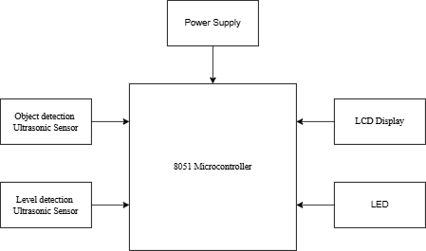

Figure 1: Block Diagram of Smart Dustbin System

3.2 Circuit Diagram
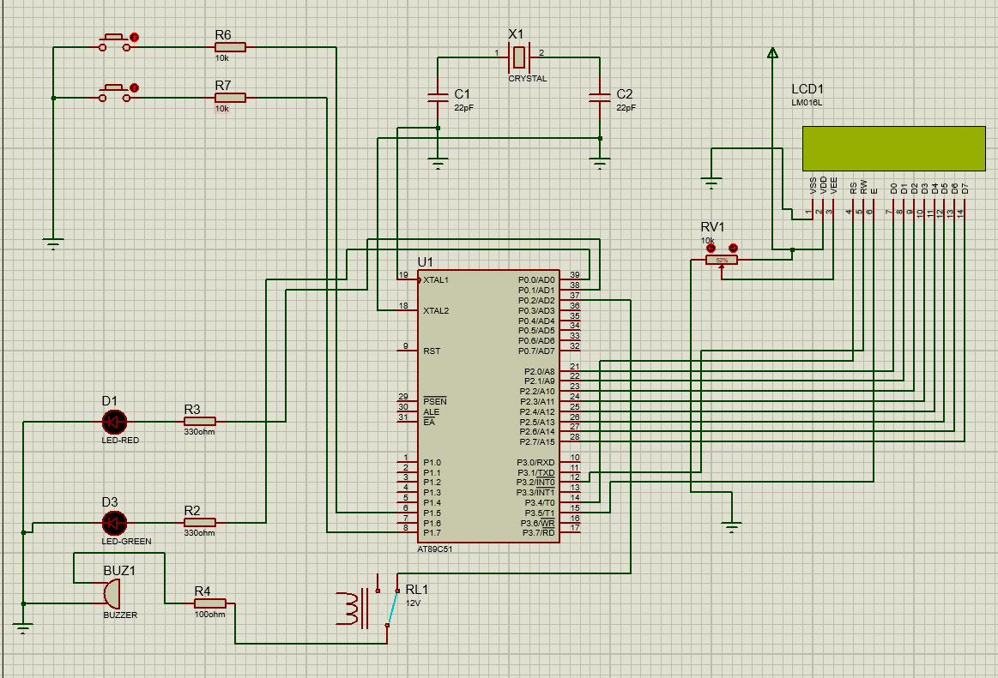

Figure 2: Circuit Diagram (Proteus Simulation

\
Table 2: Pin Connection Details

Component | Signal / Pin Name | 89C51 Connection
LCD D0-D7 | 8-bit Data Bus | P2.0 – P2.7
LCD RS | Register Select | P3.4 (T0)
LCD EN | Enable | P3.5 (T1)
LCD RW | Read/Write | GND (always write)
LED Red | Lid Open / Bin Full Indicator | P1.1
LED Yellow | Half Full Indicator | P1.2
LED Green | Lid Closed Indicator | P1.3
Buzzer | Audio Alert (Bin Full) | P1.4
BTN1 (Object) | Object Detected Input | P1.5 (active low)
BTN2 (Half) | Half Full Input | P1.6 (active low)
BTN3 (Full) | Full Input | P1.7 (active low)

3.3 Algorithm
The system operates continuously in a loop after initialization. The following steps describe the core algorithm:
Step 1: Start
Step 2: Initialize the System
Initialize the 8051 microcontroller.
Initialize the object detection sensor.
Initialize the dustbin level sensor.
Initialize the LCD display.
Keep the dustbin lid closed.
Step 3: Detect Nearby Object
Read the object detection sensor.
If an object is detected within 13 cm:
Display "Object Detected" on the LCD.
Open the dustbin lid.
Wait for a few seconds.
Close the dustbin lid.
Otherwise:
Display "No Object Detected" on the LCD.
Keep the lid closed.
Step 4: Detect Dustbin Level
Read the level detection sensor.
Determine the fill level of the dustbin.
Step 5: Display Dustbin Status
Display the dustbin fill level (empty, half, or Full) on the LCD.
Step 6: Repeat
Continuously repeat Steps 3 to 5.
Step 7: End

3.5 Tools and Techniques
Table 3: Tools and Purposes

Tool / Software | Purpose
Keil uVision 5 | Embedded C development environment and compiler for 89C51
Proteus 8 Professional | Schematic capture and full circuit simulation including LCD and LEDs
ProgiSP | Hex file programming tool for flashing compiled code to the 89C51 board
GitHub | Version control and source code management

3.6 System Specifications and Key Functions
Table 4: System Specifications

Parameter | Value
Microcontroller | 89C51 (MCS-51 compatible)
Flash ROM | 4 KB
Internal RAM | 128 bytes
Crystal Frequency | 11.0592 MHz
Lid Open Indication Duration | 3 seconds — Red LED active (300 x 10ms loop)
Lid Close Indication Duration | 3 seconds — Green LED active (300 x 10ms loop)
Half Full Display Duration | 2 seconds — Yellow LED active (200 x 10ms loop)
Full State Behavior | Red LED + Buzzer held active while BTN3 pressed
LCD Interface | 8-bit parallel, P2.0-P2.7 (data), P3.4 (RS), P3.5 (EN)
Button Logic | Active low inputs on P1.5 (BTN1), P1.6 (BTN2), P1.7 (BTN3)

Table 5: Key Functions and Descriptions

Function Name | Description
lcd_init() | Initializes the 16x2 LCD in 8-bit mode with display ON, cursor OFF
lcd_cmd() | Sends a command byte to the LCD controller by setting RS=0
lcd_dat() | Sends a data byte (character) to the LCD by setting RS=1
lcd_print() | Prints a null-terminated character string to the LCD at current cursor position
lcd_goto() | Moves the LCD cursor to the specified row (0 or 1) and column position
lcd_clear() | Sends the clear display command (0x01) and waits for execution
lcd_pulse() | Generates a single EN high-low pulse to latch data or command into the LCD
screen_ready() | Displays 'SMART DUSTBIN / STATUS: READY' on the LCD
screen_open() | Displays 'SMART DUSTBIN / LID OPEN - RED ON' on the LCD
screen_close() | Displays 'SMART DUSTBIN / LID CLOSED - GRN' on the LCD
screen_half() | Displays 'SMART DUSTBIN / BIN HALF FULL!' on the LCD
screen_full() | Displays 'SMART DUSTBIN / ** BIN FULL !!**' on the LCD
all_off() | Turns off all LEDs and buzzer by clearing their output pins
btn_input() | Sets BTN1, BTN2, BTN3 pins as inputs by writing logic 1
delay_ms() | Busy-wait software delay loop calibrated for 11.0592 MHz crystal
delay_us() | Microsecond-level busy-wait delay used for LCD timing pulses

3.7 Testing and Debugging
Table 6: Test Cases and Results

Test No. | Test Case / Description | Expected Result | Outcome
T-01 | Power on and check LCD startup | LCD shows 'SMART DUSTBIN / WELCOME!' | Pass
T-02 | System idle, no buttons pressed | LCD shows 'STATUS: READY', all LEDs and buzzer off | Pass
T-03 | Press BTN1 — object detected | Red LED turns ON, LCD shows 'LID OPEN - RED ON' | Pass
T-04 | Auto-transition from open to close | After 3 sec: Red LED OFF, Green LED ON, LCD shows 'LID CLOSED - GRN' | Pass
T-05 | Auto-return after lid close phase | After 3 sec: Green LED OFF, LCD returns to READY | Pass
T-06 | Press BTN2 — half full | Yellow LED ON, LCD shows 'BIN HALF FULL!' | Pass
T-07 | Auto-return from half full | Yellow LED OFF after 2 seconds, LCD returns to READY | Pass
T-08 | Press and hold BTN3 — full | Red LED ON, Buzzer ON, LCD shows '** BIN FULL !!**' | Pass
T-09 | Release BTN3 from full state | All outputs OFF, LCD returns to READY | Pass
T-10 | BTN3 priority over BTN1 and BTN2 | Full state takes precedence regardless of other buttons | Pass
T-11 | Red LED shares open and full states | Red LED activates correctly for both BTN1 open phase and BTN3 full state | Pass
T-12 | Green LED activates only after open cycle | Green LED does not activate during BTN2 or BTN3 states | Pass
T-13 | LCD display quality check | All characters readable, no black blocks or garbled text | Pass
T-14 | BTN1 ignored while in state 1 open phase | Pressing BTN1 again during open cycle does not restart sequence | Pass
T-15 | Buzzer stays active while BTN3 held | Buzzer remains on continuously as long as BTN3 is pressed | Pass

CHAPTER 4: METHODOLOGY AND SCHEDULING
This chapter describes how the project was planned, divided among team members, and executed over the course of the development period. The project followed a staged development approach, starting from research and design and progressing through coding, hardware assembly, testing, and finally documentation.

4.1 Development Methodology
The project was divided into clearly defined phases. Each phase had specific deliverables and was assigned to team members based on their area of focus. Hardware and software development were carried out in parallel where possible, with integration and testing performed after each major component was completed individually. The embedded C code was developed in Keil uVision 5 and compiled to a hex file, which was then flashed to the 89C51 board using ProgiSP. Circuit simulation in Proteus 8 was used to verify the design before hardware assembly.

4.2 Project Schedule
Phase 1: Research and Requirement Analysis
- Review of project requirements and definition of system scope
- Study of 89C51 datasheet, LCD HD44780 controller, and LED/buzzer control methods
- Research on waste management automation and related embedded systems literature
- Preparation of initial hardware component list
Phase 2: System Design
- Design of block diagram and system flowchart
- Circuit design and simulation in Proteus 8 Professional
- Initial embedded C code structure written in Keil uVision 5
Phase 3: Coding and Hardware Assembly
- Complete embedded C code developed: LCD functions, multi-state LED logic, buzzer control, timed sequences for open and close phases
- Hardware assembled on breadboard and connections verified
- Hex file compiled and flashed to 89C51 using ProgiSP
Phase 4: Testing and Debugging
- Individual module testing: LCD display, each LED state, buzzer activation
- Integration testing of full timed sequence: Red LED open (3 sec) to Green LED close (3 sec) cycle
- Full system end-to-end testing across all three states and priority logic
Phase 5: Documentation
- Full project report written according to college format
- Appendices prepared with hardware images and component diagrams

4.3 Roles and Responsibilities

Table 7: Team Member Roles and Responsibilities

Team Member | Assigned Responsibilities
Bipin Tamang | Overall project coordination and milestone tracking, core embedded C architecture; LCD interfacing and display coding, multi-state LED timed sequence logic, final system integration and end-to-end testing
Dikshant Khanal | Literature review and background research, block diagram and flowchart design, Proteus 8 circuit design and simulation, hardware component procurement, project report writing and documentation
Soviet Khaling Rai | Buzzer circuit and code, LED indicator circuit assembly and verification, hardware assembly and physical testing on breadboard, appendix preparation with hardware photographs

4.4 Gantt Chart

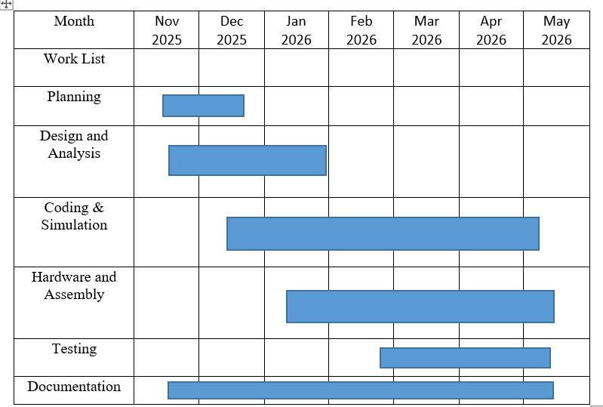

Figure 4: Project Gantt Chart

CHAPTER 5: CONCLUSION
The Smart Dustbin system was successfully designed, implemented, and tested as a complete embedded system capable of indicating lid open and close states through timed LED sequences, monitoring bin fill levels, and providing immediate local visual and audio alerts.
The system uses the 89C51 microcontroller to poll three input states corresponding to object detection (BTN1), half-full (BTN2), and full (BTN3) conditions. Upon object detection, the red LED activates for 3 seconds to indicate the lid is open, then automatically transitions to the green LED for 3 seconds to indicate the lid has closed, before returning to the ready state. The yellow LED activates for 2 seconds upon half-full detection. The red LED and buzzer activate together and remain active while the full condition is held, clearing when BTN3 is released. All state transitions are displayed in real time on the 16x2 LCD display.
The final system was verified through end-to-end testing: all three input states correctly triggered their corresponding LED and buzzer outputs, the LCD displayed accurate status messages at all times, and the timed red-to-green LED sequence for the lid open-close cycle operated correctly with precise 3-second intervals.

5.1 Limitations
- The current prototype uses pushbutton inputs to simulate fill levels and object detection; ultrasonic sensors would replace these in a production version
- Only local visual and audio alerts are provided; no remote notification is included in this version
- The green LED lid-close timer runs for a fixed 3 seconds regardless of actual bin usage patterns
- The red LED is shared between the lid-open state and the bin-full state; a separate LED for each would improve clarity in a production design
- The system does not have a standalone battery backup; it requires a continuous 5V supply

5.2 Future Scope
- Integration of HC-SR04 ultrasonic sensors to replace pushbuttons for real contactless fill-level measurement and object detection
- Addition of a GSM module for remote SMS notification to waste management authorities when bin is full
- Integration with a cloud platform for remote monitoring of bin fill levels across multiple dustbins on a city-wide dashboard
- Addition of a GPS module for location-aware routing of waste collection vehicles
- Development of a dedicated mobile application for real-time push notification alerts to registered contacts
- Deployment of multiple interconnected smart dustbins with a centralized web dashboard for city-wide waste management

CHAPTER 6: REFERENCES
[1] M. A. Mazidi, R. D. McKinlay, and J. G. Causey, The 8051 Microcontroller and Embedded Systems: Using Assembly and C, 2nd ed. Upper Saddle River, NJ, USA: Pearson Prentice Hall, 2006.
[2] Atmel Corporation, "AT89C51: 8-bit Microcontroller with 4K Bytes Flash," Atmel Datasheet, 2000. [Online]. Available: https://www.microchip.com/en-us/product/AT89C51
[3] P. K. Sinha and P. Sinha, "IoT Based Smart Garbage Monitoring System," International Journal of Engineering Research & Technology, vol. 5, no. 3, 2016.
[4] R. Kokate and A. Patil, "Smart Dustbin: An Automated Waste Monitoring System," International Journal of Computer Applications, vol. 105, no. 17, pp. 1-4, Nov. 2014.
[5] Hitachi Semiconductor, "HD44780U LCD-II Controller/Driver Datasheet," Hitachi, 1998.
[6] Keil Microvision, "Keil MDK uVision 5 User's Guide," Arm Ltd., 2021. [Online]. Available: https://www.keil.com/support/man/docs/uv4/. [Accessed: May 2026].

APPENDIX A: HARDWARE IMAGES

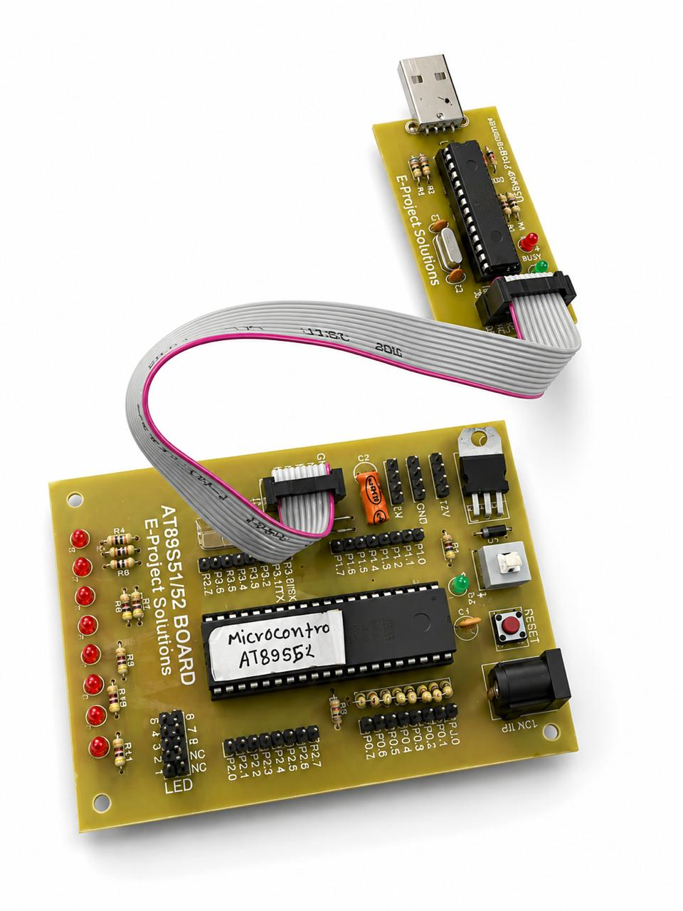

Figure 5: 89C51 Microcontroller Development Board

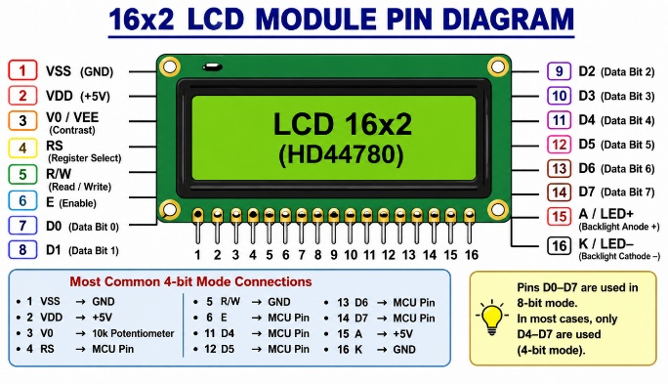

Figure 6: 16x2 LCD Display Module

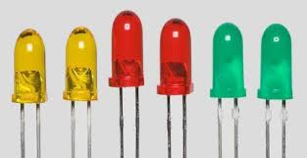

Figure 7: Red, Yellow and Green LED Indicator

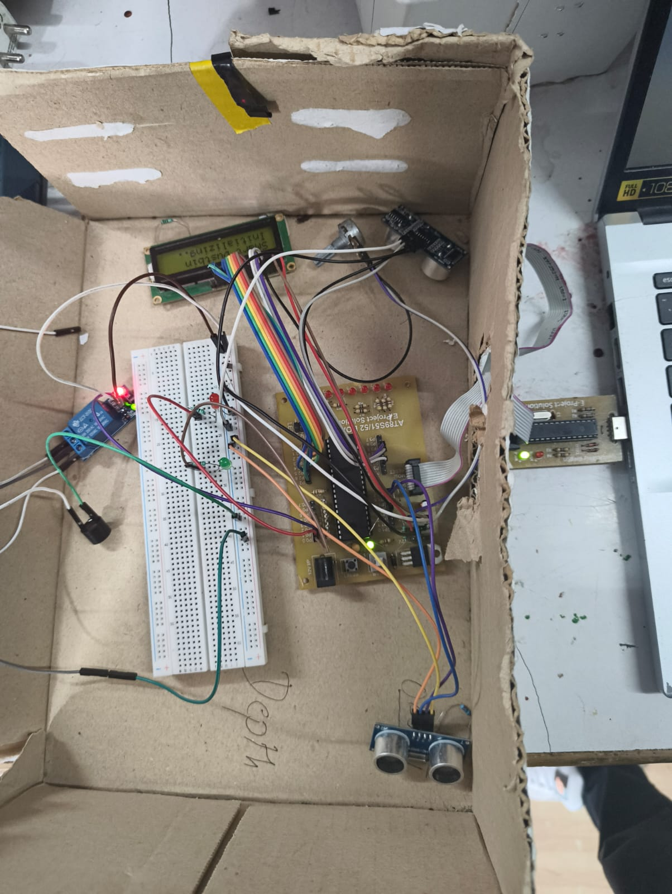

Figure 8: Full hardware connection
APPENDIX B: PIN DIAGRAMS

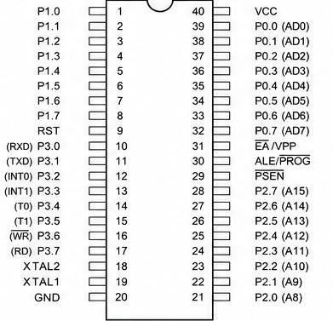

Figure 11: AT89S52 Microcontroller Pin Diagram

